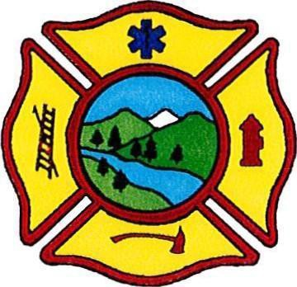
17th ANNUAL LYONS FIREFIGHTERS
ASSOCIATION CAR SHOW
DATE: TBA
TIME: DOORS OPEN AT 9:00 AM
AWARDS GIVEN AT 2:15 PM
JOIN US AT LYONS FIRE DISTRICT
1114 MAIN STREET LYONS, OREGON

REGISTRATION: $15.00

Cut here >> <<Cut here

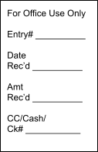CAR: YEAR: _____________ MAKE: ____________
TBA
NAME:

ADDRESS:
(CITY)
(STATE)
(ZIP CODE)
COLOR: ____________ MODEL: ___________

PHONE: EMAIL:

Vendor & Merchandise Information

ENTRIES CAN BE MAILED OR FAXED TO: LYONS FIRE DEPARTMENT
PO BOX 179, LYONS, OR 97358
FAX: 503-859-2422

*CASH OR CHECKS MADE PAYABLE TO: LYONS FIREFIGHTER ASSOCIATION

FOR MORE INFORMATION, CALL 503-859-2410.

